Experiment No : 14 Program to plot the graphs of various mathematical formula

import matplotlib.pyplot as plt

def fact(x):
if x == 0 or x == 1:
return 1

return x * fact(x - 1)

def sin(x):
j = 1
val = 0
for i in range(1, 20):

term = (x ** j) / fact(j)
if i % 2 == 0:
val = val - term
else:
val = val + term

j = j + 2
return val

print("MENU")
print("1.y = x")
print("2.y = x^2")
print("3,y = sin(x)")
print("4,y = 2^x")
print("5.y = x^0.5")
print("6.EXIT")

while 1:

x = int(input("Enter the Option : "))
xc = []
floater = -10
while floater < 10 :
xc.append(floater)
floater = floater + 0.1

if x == 1:
yc = [i for i in xc]
elif x == 2:
yc = [i * i for i in xc]
elif x == 3:
yc = [sin(i) for i in xc]
elif x == 4:
yc = [2**i for i in xc]
elif x == 5:
xc = range(0, 50)
yc = [i**0.5 for i in xc]
else:
break
plt.plot(xc, yc)
plt.show()

Output :
MENU
1.y = x
2.y = x^2
3,y = sin(x)
4,y = 2^x
5.y = x^0.5
6.EXIT
Enter the Option: 1
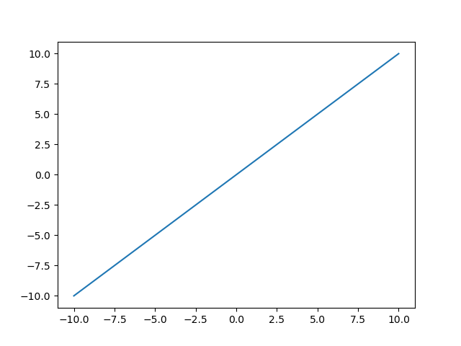

Enter the Option : 2
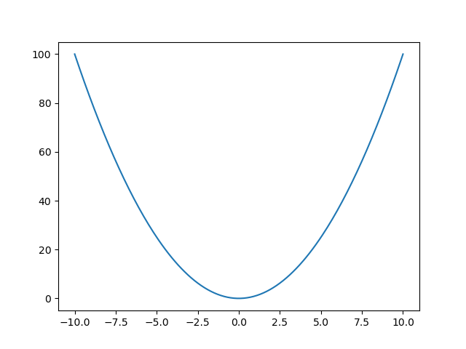
Enter the Option : 3
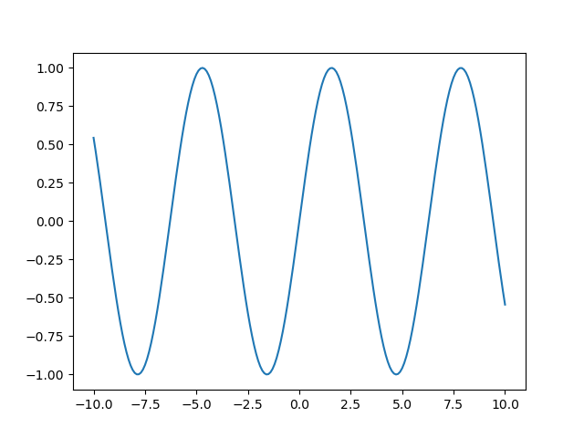
Enter the Option : 4
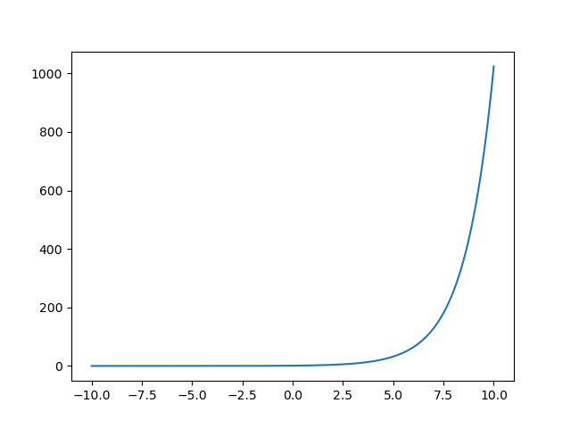
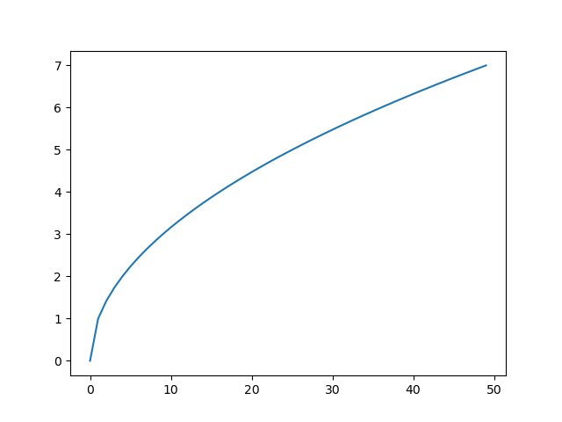
Enter the Option : 5
Enter the Option : 6

